**AWS TASK-3**

**Step1:**

Creating the S3 Bucket and blocking all the public access

Screenshot Mentioned Below

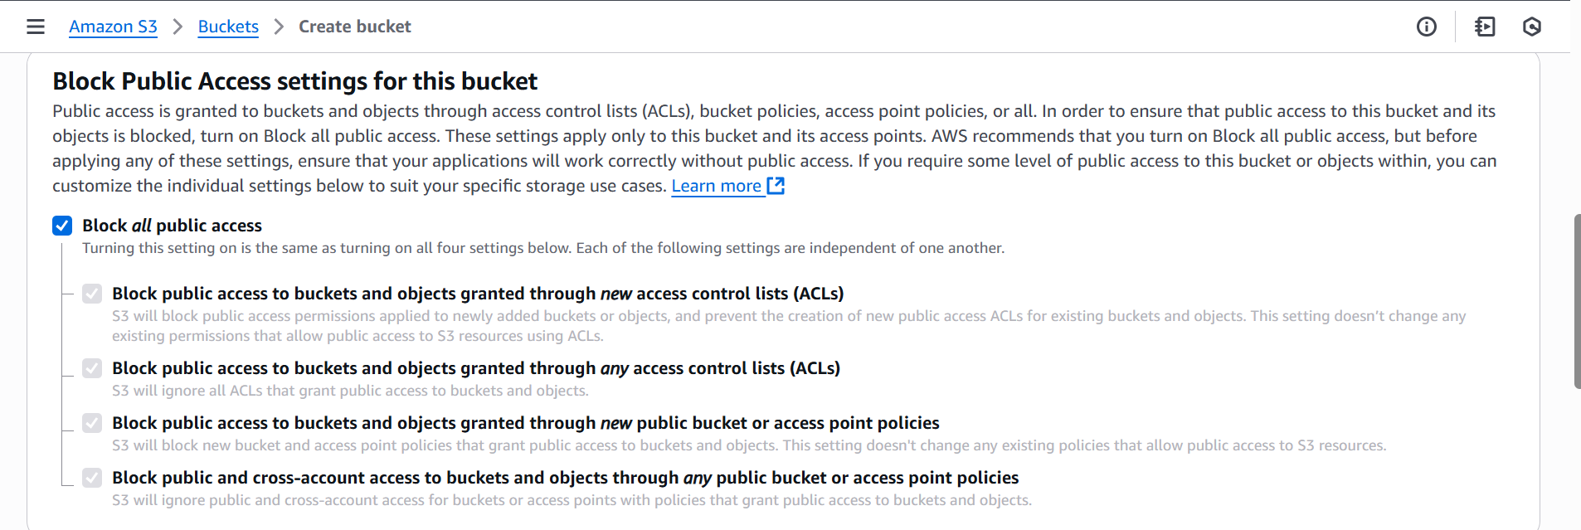

Uploading the file into the S3 Bucket

One of my pem file is added into the S3 Bucket

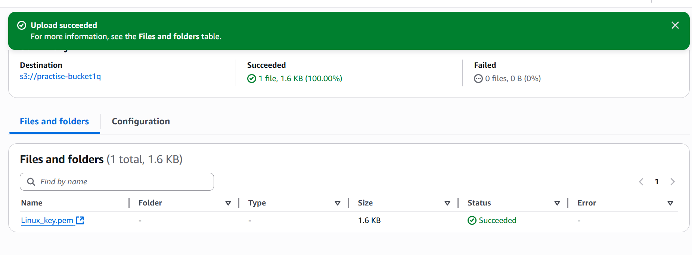

Step2:

From the S3 Bucket itself we can See the Log using

**Server access logging there I enabled those** thing and we can see through the Cloudwatch

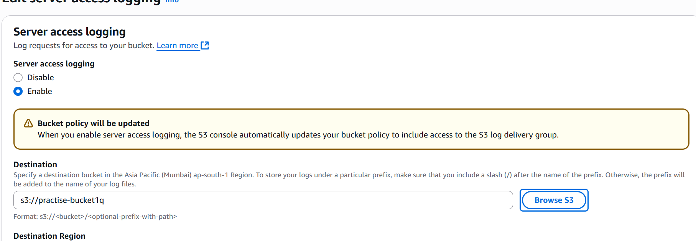

Step3:

Created the cloud trial and push the cloud trial in the cloud watch then only we will be able to see the Logs Screeenshot mentioned Below:

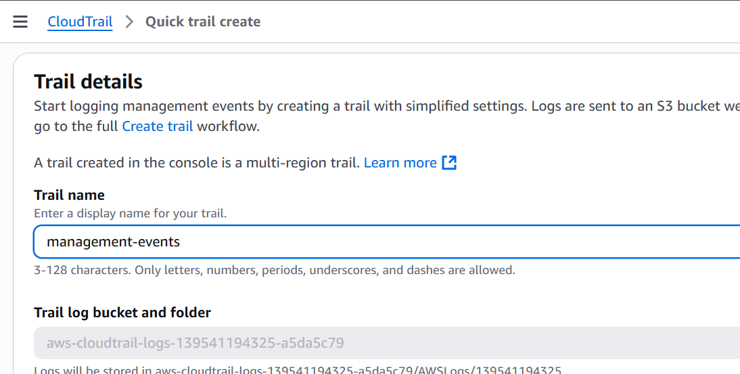

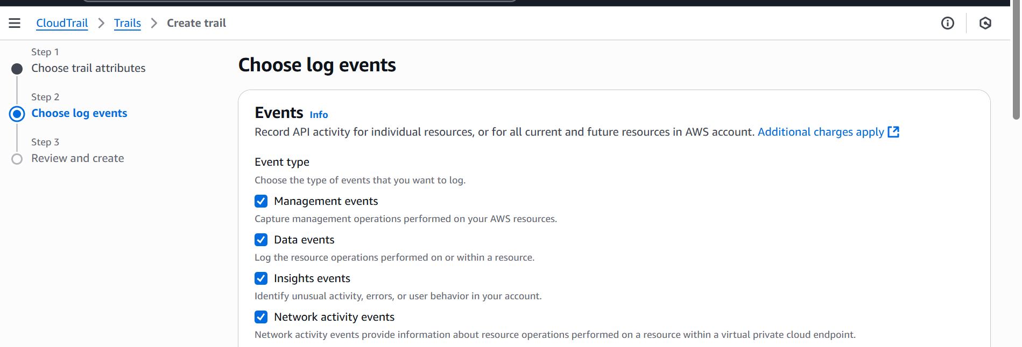

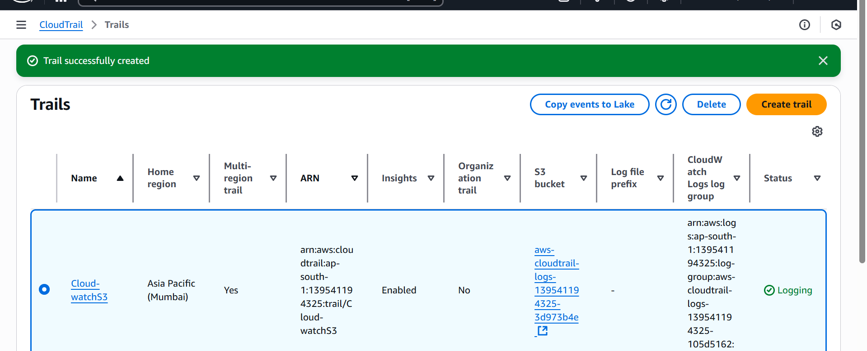

Now we can see the Log through the cloudwatch

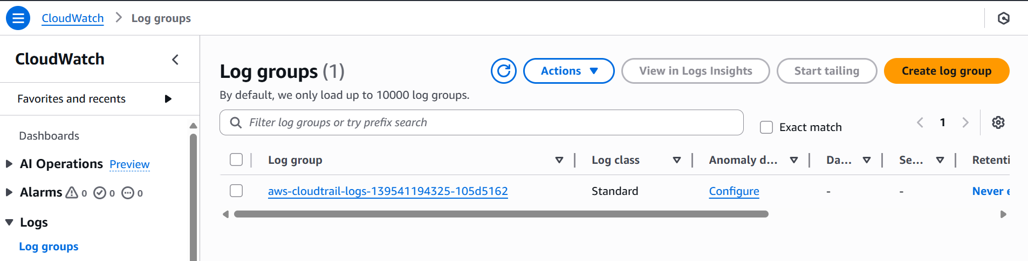

2). Using the LoadBalancer that is separate

Step1:

Iam creating the 2 instance of EC2 linux

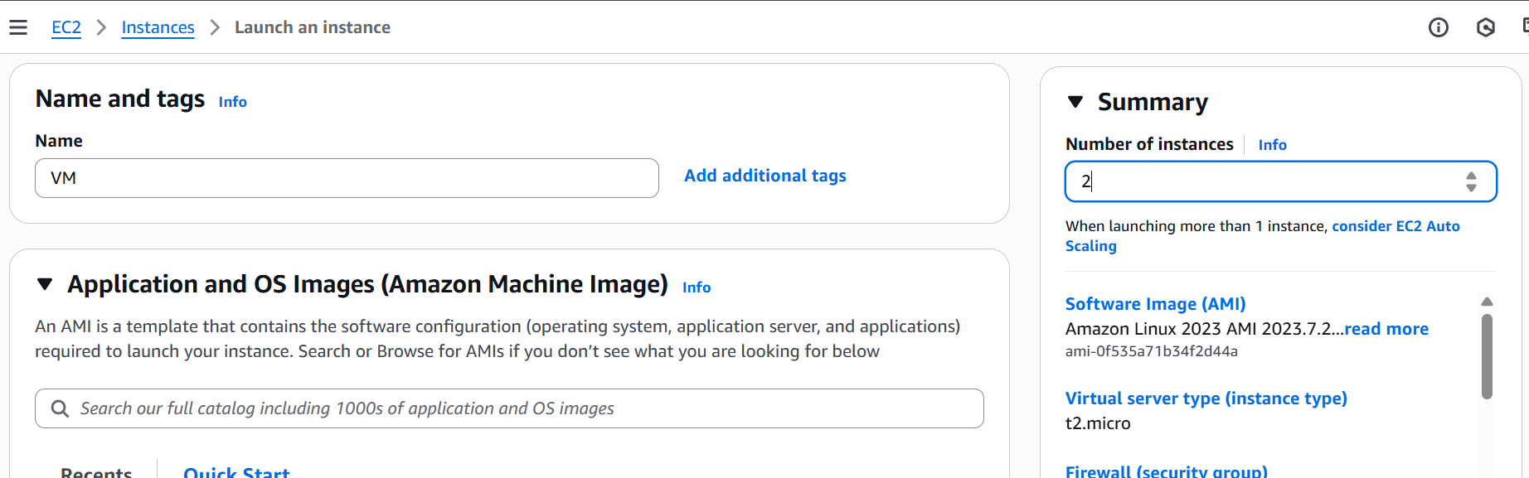

Step2:

In Vm1 aim going to create ngnix and Vm2 Apache so that they routing via the Load balancer

Screenshot mentioned Below:

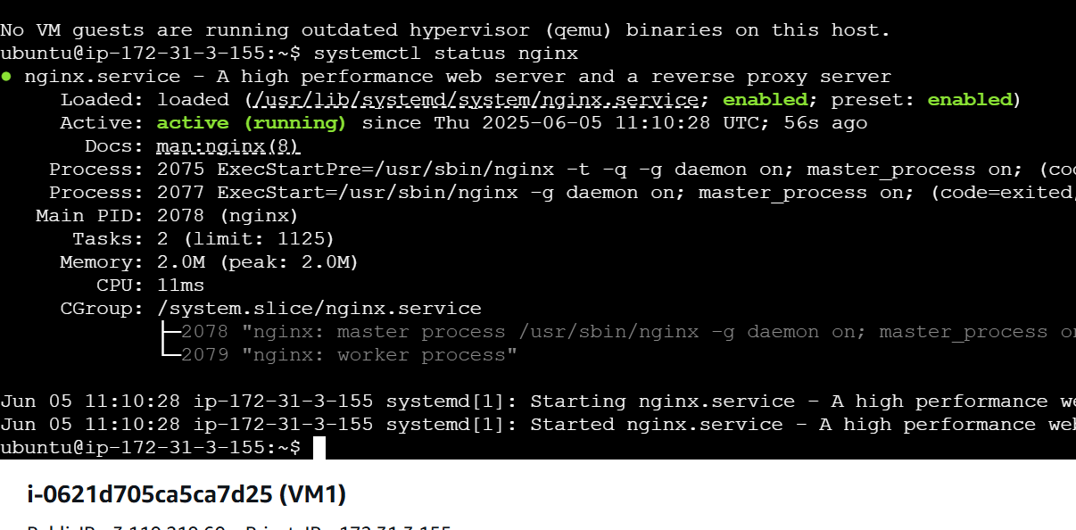

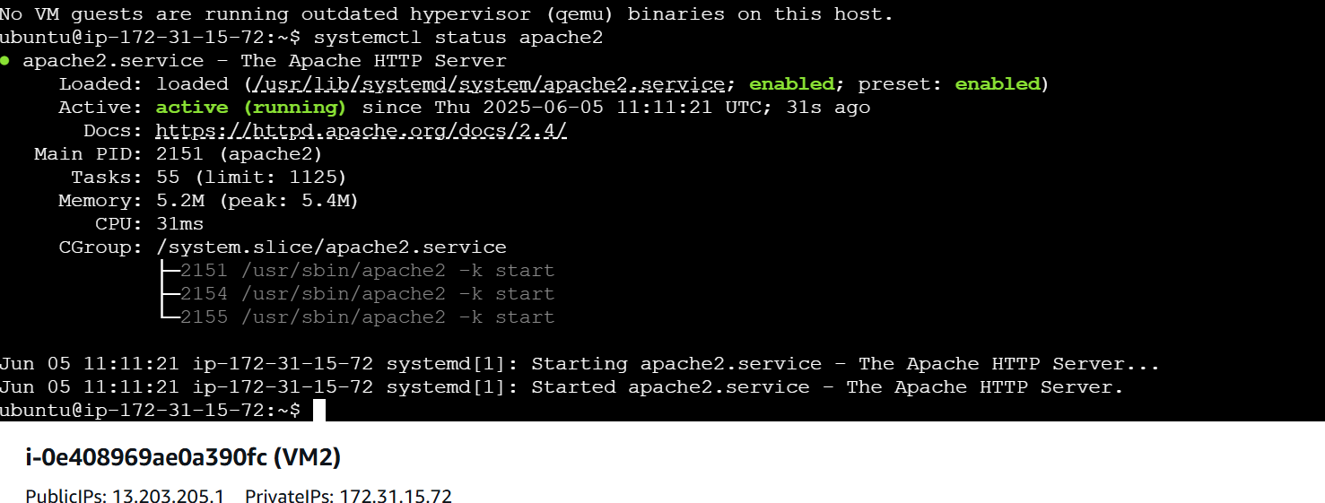

Step3: We need to create an Target Group and Load balancer

So Vm1 to ALb1 choose including oending same as VM 2 also I mentioned the image

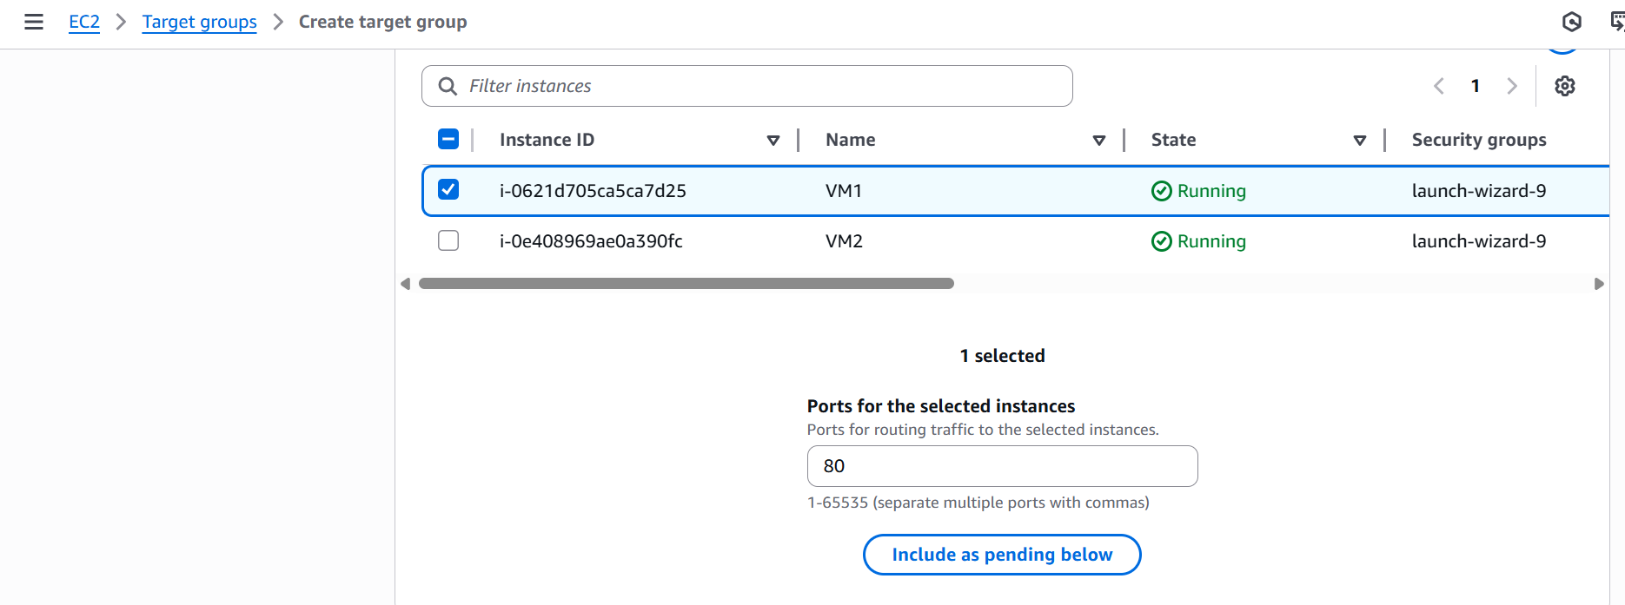

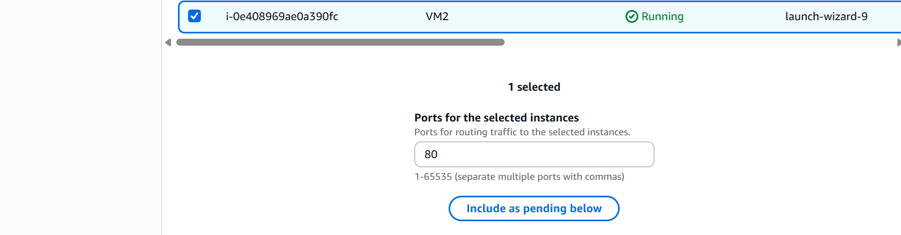

Created the Loadbalancer and adding the listener through the LB and adding the Rule

If I hits this DNS via Load balancer the Web page is Opening using the DNS: http://alb-target-1318554503.ap-south-1.elb.amazonaws.com/

